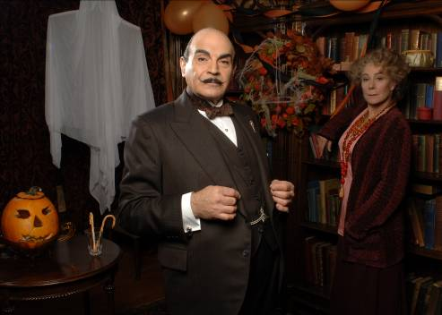
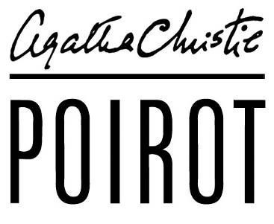

HALLOWE’EN PARTY





PRODUCTION NOTES

***The information contained herein is strictly embargoed from all press use, non commercial publication, or syndication until Monday 18th October 2010***

Introduction Page 3
Cast list Page 4
Interview with David Suchet Page 5
Interview with Zoë Wanamaker Page 7
Synopsis Page 8
Agatha Christie’s 120th anniversary Page 9

ITV Press Office
Press contacts:
Natasha Bayford - 0161 952 6209 / natasha.bayford@itv.com
Kate Richards - 020 7157 3039 / kate.richards@itv.com
Picture contact:
Patrick Smith - 0207 157 3044 / patrick.smith@itv.com

INTRODUCTION

David Suchet and Zoë Wanamaker reunite in
HALLOWE’EN PARTY

Award winning actress Zoë Wanamaker (My Family, Harry Potter and the Philosopher’s Stone) makes a welcome return, alongside David Suchet, as Ariadne Oliver in Hallowe’en Party.

Adapted by actor, screenwriter and novelist, Mark Gatiss, Hallowe’en Party also stars Amelia Bullmore (Bellamy’s People, Ashes to Ashes), Deborah Findlay (Gunrush, Silent Witness), Georgia King (Little Dorrit, St. Trinian’s: The Legend of Fritton’s Gold), Julian Rhind-Tutt (Green Wing, Oliver Twist), Sophie Thompson (A Room With A View, EastEnders), Paul Thornley (Mutual Friends, Love Soup), Eric Sykes (The Goon Show), Fenella Woolgar (Doctor Who, Jekyll) and Timothy West (Bleak House, A Room With A View).

When Ariadne Oliver attends a children's Hallowe'en party in Woodleigh Common with her friend Judith, a young girl boasts of having witnessed a murder years before. Later that evening Joyce Reynolds is found dead, drowned in an apple-bobbing bucket in the library. It appears that any one of the guests could have slipped out in the dark during a game of Snapdragon and murdered her.

At the request of Ariadne, Hercule Poirot arrives at Woodleigh Common to investigate the murder. Though Joyce was dismissed as a fantasist, Poirot is convinced her story has some truth to it. When he seeks out the local gossip, he discovers that there have been a number of suspicious deaths in the village in recent years which Joyce could have witnessed. But while Poirot pieces together the facts, another child is found murdered. Could a forged codicil, a missing au pair and a secret love affair be the key to solving the crime?

Hallowe’en Party is directed by Charles Palmer (Poirot: The Clocks, Lark Rise to Candleford, Doctor Who) and the producer is Karen Thrussell (Agatha Christie’s Marple).

The Poirot films are co-produced by ITV Studios and Agatha Christie Ltd, a Chorion company, and US network WGBH. Mammoth Screen’s Michele Buck and Damien Timmer executive produce Poirot on behalf of ITV Studios. Rebecca Eaton is executive producer for WGBH, with David Suchet as associate producer. ITV Global holds international distribution rights.

CAST LIST

HERCULE POIROT DAVID SUCHET
ARIADNE OLIVER ZOË WANAMAKER
ROWENA DRAKE DEBORAH FINDLAY
JUDITH AMELIA BULLMORE
MICHAEL GARFIELD JULIAN RHIND-TUTT
REV. COTTRELL TIMOTHY WEST
MISS WHITTAKER FENELLA WOOLGAR
FRANCES DRAKE GEORGIA KING
EDMUND DRAKE IAN HALLARD
MRS GOODBODY PAOLA DIONISOTTI
MRS REYNOLDS SOPHIE THOMPSON
INSPECTOR RAGLAN PAUL THORNLEY
FULLERTON ERIC SYKES
JOYCE REYNOLDS MACY NYMAN
LEOPOLD REYNOLDS RICHARD BREISLIN
GEORGE DAVID YELLAND
MRS LLEWELLYN-SMYTHE PHYLLIDA LAW
OLGA SEMINOFF VERA FILATOVA

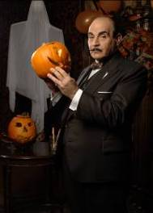

INTERVIEW WITH DAVID SUCHET

“Hallowe’en Party - now that is Agatha Christie at her darkest. This is really, really serious and Poirot is out of his environment - he’s moved out of London to the country to solve this crime. I did find it a very moving story in particular because we were actually filming it on Halloween and that made it very poignant for me.”

Hallowe’en Party reunites Poirot with Ariadne Oliver, one of the few women Poirot regards as a friend. “Poirot and Ariadne Oliver are really good friends and, if you had a compendium of Poirot, Ariadne Oliver would be one of the women in his life. He strikes a deep friendship with Ariadne, although not in any way from the heart. It’s from the head! I think the reason Poirot likes Ariadne is because she is a crime writer and she provides for him another mind that he can tap. She will come forward with her crime writer’s solutions to the situations they find themselves in. Poirot does have a very soft spot for her. I know that because she is the only woman that Poirot ever, in the whole collection of films, calls by her Christian name without a pre-fix.

“It’s also great fun with Ariadne Oliver because Poirot gets kindly irritated with her, and she gets kindly irritated with him. I think everybody likes to see Poirot with a woman. I think Zoë and I, having known each other for years and having worked in the theatre together, we bring our own knowledge of each other to that relationship. I would agree also with the fact that Ariadne sends Poirot up. Of course she does, because Ariadne is a writer and so is Agatha Christie. Agatha Christie often points fingers and sends up people she is writing about.”

As an Associate Producer on Poirot, David is able to fulfil a promise he made to Agatha Christie’s own daughter over 20 years ago...

“I feel a tremendous responsibility to Agatha Christie. When I first accepted this role, I was taken out by Agatha Christie’s daughter Rosalind Hicks and I remember her saying to me over the table, ‘We want Poirot played as we believe mother wrote it. You can smile with Poirot but we must never laugh at him.’ They chose me for Poirot: it was nobody else’s choice. They knew the way I worked and my first duty has always been to my author, my playwright. I think they knew in casting me that I would be loyal to Agatha Christie and I have been loyal from day one. It’s a huge responsibility that should never to be taken for granted.

“Being an associate producer gives me the privilege and permission to come outside my role as an actor and to talk to everyone on the set, whatever their position, about their responsibilities and how to maintain the style of each film. I care desperately that we don’t turn Agatha Christie into a “chocolate box” show and play it tongue and cheek – these are crime stories, they are serious stories with murders and kidnappings. Into that world of crime comes Poirot with his wonderful eccentricity: although that can make people smile, but watch out that smile will soon turn when you realise he is the greatest detective in the world.”

David is continually delighted by Poirot’s popularity around the world, especially the fact that he is loved by all generations, from children to the elderly.

“What is it about this little man? I’m now getting letters from seven year olds who have suddenly got hooked! I recently sent photographs to two eight year old twins who come home from school and make their mother put on Poirot! In the same month I sent a box of chocolates to someone who was 94 in an old people’s home. Almost 90 years difference in age yet they are watching the same programme.”

Having played Poirot for over 20 years, David is now able to react instinctively as him, an instinct born out of growing older with the man he refers to as his “life-long companion”.

“Poirot has had to change over the years as I’ve played him because he has grown and developed into a deeper and more rounded human being. There is so much I know about him that it’s not hard for me to put him into any situation or any emotional state: it’s just a question of me finding the right state within myself. I can take him anywhere in the world and know how he would react. Consequently, knowing him as deeply as I do, I know his vulnerable points. It’s those vulnerable areas that have developed, almost in spite of myself. It’s not been a conscious choice of ‘I will now show this side of Poirot’ but he finds himself in these situations where I just know him so well that I let him come out. Hopefully, over the years, he’s got more dimension than he had at the very beginning and that’s because I’ve grown with him.”

Playing Poirot now comes so naturally to David that he continues to use his distinctive Belgium accent between takes on the film set, a necessity largely dictated by the restriction of a certain moustache...

“The character is so extreme and I wear this huge padding and moustache, which limits the movement of my top lip, so I have a reputation of being ‘Poirot’ in between set ups and scenes. To a certain extent that is true, but to a certain extent it’s not true, because I’m not actually Poirot but I will speak as him. I can’t move my mouth very easily anyway and it’s a very particular accent, which sounds very natural coming out of him but it is something that is not the natural way of speaking for me. To walk around in that padding, in that suit, I can’t just come off the set and be David Suchet and then the next minute be called back onto the set and become Poirot. It’s not an actor’s indulgence: it’s to maintain a certain aspect of the role that I can then take immediately back onto the set. With a very small gear change I’m Poirot again.”

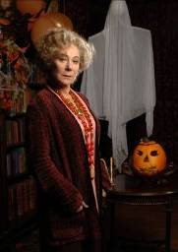

INTERVIEW WITH ZOË WANAMAKER

This is Zoë Wanamaker’s fourth outing as Ariadne Oliver: she has also played the eccentric writer in Cards On The Table (2005), Third Girl (2008) and Mrs McGinty’s Dead (2008). It is a role Zoë always enjoys reprising and would love to see more of...

“I think Ariadne is a wonderful character – I’m deeply fond of her. I think Agatha Christie wrote Ariadne Oliver as a send up of herself. Ariadne is a crime fiction writer and is pressured by her publishers to constantly produce her Sven Hjerson books: it was the same with Agatha and her publisher constantly getting her to do more Poirot stories! Ariadne is the complete antithesis of Poirot himself, who’s anal and self regarding and egotistical. She has less of an ego but has this fantastic imagination and is slightly mocking.

“What’s great about Ariadne is her relationship with Poirot. They respect each other but they’re slightly rude to each other, which is wonderful. I think Poirot needs to be sent up a lot and Ariadne does that. I enjoy their relationship very much. It works because they enjoy each other’s eccentricities and respect each other’s minds. Ariadne would make a wonderful detective – she has a great instinct and Poirot constantly mentions that it’s her instinct which often points him in the right direction. The scripts are a joy to read, because of that relationship and I love going back to her each time.”

As well as her fondness for Ariadne, it is the whole package which continues to attract Zoë to Poirot. “All the characters in an Agatha Christie book are so incredibly beautifully drawn - they’re a joy to play because they have so many layers. I did a Marple (A Murder is Announced) and I enjoyed that too. Also it’s costume drama, which is great fun to do. It’s dressing up for actors and they just love it - it’s a great opportunity for actors to become characters off the page. Not only are the films beautiful to look at but you are watching really good actors perform. It’s complete escapism in a gentle way. Each story is also a great opportunity for filmmakers to produce a really good piece of film - the details in the costume and the period are always fascinating.”

Despite this being her fourth Poirot, Agatha Christie’s plotting continues to interest Zoë, both as an actress and reader. “I don’t ever guess the murderer because the murderer always comes from left field - Agatha’s very good at throwing you off the scent completely. I hadn’t actually read the books until I started playing Ariadne, when I clawed my way through every one of her stories. She’s wonderful with conversations, especially those between Ariadne and Poirot. And some of it is quite shocking - I don’t know what Agatha had in her head when she wrote Hallowe’en Party! But why not - it’s interesting and very brave that she wrote some of the shocking stories she did.”

SYNOPSIS

The following synopsis is published in the production notes for forward planning purposes only. Please do not reproduce entirely and do not publish the end of the story. Many thanks.

When Ariadne Oliver (Zoë Wanamaker) attends a children's Halloween party in Woodleigh Common with her friend Judith (Amelia Bullmore), a young girl boasts of having witnessed a murder years before. Joyce Reynold's (Macy Nyman) story is heard by all at the party, including her strange brother Leopold (Richard Breislin), the impeccable hostess Rowena Drake (Deborah Findlay), her bookish son Edmund (Ian Hallard) and the local Reverend Cottrell (Timothy West). Miss Whittaker (Fenella Woolgar), the church organist, and Frances Drake (Georgia King), Rowena's feisty daughter, are dismissive of the girl’s story. Later that evening Joyce is found drowned in an apple-bobbing bucket in the library. Any one of the guests could have slipped out in the dark during a snapdragon game and held her head under the water.

Hercule Poirot (David Suchet) arrives in Woodleigh Common at the request of his friend Ariadne to investigate the murder. On the way he meets handsome village gardener Michael Garfield (Julian Rhind-Tutt), who discovered the village three years ago when he was employed to landscape a garden and has been there ever since.

Though local Inspector Raglan (Paul Thornley) dismisses Joyce's claim and even her step-mother Mrs Reynolds admits her daughter was a liar, Poirot is convinced Joyce's story has some truth to it. When he seeks out the local gossip, eccentric charwoman Mrs Goodbody (Paola Dionisotti), Poirot discovers that there have been a number of suspicious deaths in the village in recent years, any one of which Joyce could have been referring to: a drowned school teacher, a solicitor's clerk stabbed in the street and the death of a rich old lady.

The school teacher’s death was reported to be an accident caused by drinking, but her close friend Miss Whittaker is adamant Beatrice’s death was explained away on account of their love for one another, a love that scandalized the village school. Legal clerk Lesley Ferrier, who was Mrs Reynold’s lodger and Frances Drake’s rumored lover, was knifed by a disguised assailant as he stood on a street corner. And Rowena Drake’s elderly aunt Mrs Llewellyn-Smythe (Phyllida Law) had a heart attack under the care of a foreign au pair the Reverend Cottrell had arranged as part of a goodwill scheme.

The family is horrified to discover from family solicitor Mr Fullerton that Mrs Llewellyn-Smythe had left her riches to the young nursemaid Olga Seminoff - that is until the codicil was found to be faked and Olga disappeared.

While Poirot pieces together the facts, another child is found drowned in the river. Could a forged codicil, a missing au pair and a secret love affair be the key to solving the crime? And can Poirot act in time to save Judith's ethereal daughter Miranda when he realises she is in grave danger?

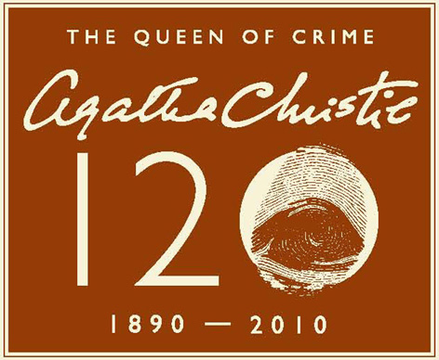

Worldwide celebrations continue in 2010 for
Agatha Christie’s 120th anniversary

www.agathachristie.com

From Turkey to Torquay, Japan to Brazil, 2010 has been packed with festivities the world over to mark the 120th anniversary year of Agatha Christie.

Central to the celebrations was the creation of the infamous Delicious Death chocolate cake featured in the 1950 Miss Marple novel, A Murder is Announced. The British cake baker and actress Jane Asher created the recipe for fans around the world for their own celebrations in Christie Week, 12- 19 September. The cake was served at assorted venues around the world associated with the Queen of Crime, including at the opening of the Pera Palace Hotel in Instanbul and the Agatha Christie Festival in Torquay which this year attracted a record number of visitors. The highlight of the week, however, had to be when Google honoured Christie’s 120th birthday on 15 September with a special ‘Google Doodle’, recognised by millions around the world.

Celebrations still to come in 2010 include:

- An Agatha Christie celebratory dinner at the Ritz Carlton, Osaka, Japan

- An Agatha Christie Weekend at the BFI in London Friday 19 to Sunday 21 November with screenings of rare and unusual adaptations of Agatha Christie’s work. It will be accompanied by special on-stage events.

- An Agatha Christie-themed tea dance at the Southbank in London on Tuesday 27 December

Ninety years after she wrote her first novel, Agatha Christie remains the best-selling author of all time and has, to date, sold over two billion books worldwide. 2010 is also the 80th anniversary of Miss Marple’s first appearance in print and the 90th of Christie’s Belgian sleuth, Hercule Poirot. Over 4 million books, graphic novels, audiobooks, DVDs, games and items of merchandise are sold each year, which means something Christie-related is sold every eight seconds somewhere in the world.

It’s no surprise that Christie has such international appeal. In 1922, the Trade Mission, on which she accompanied her first husband Archie Christie, took her all over the world including South Africa, Honolulu and Canada via planes, trains and automobiles, providing rich detail for her murder mysteries. She even based one of her murderers (at his request) on her husband’s boss! Her clear and direct prose means her books translate extremely well, and they are now available in over 45 different languages.

In an extraordinary writing career that spanned more than half a century, Agatha Christie wrote eighty novels and short story collections. She also wrote over a dozen plays, including The Mousetrap which is now the longest running play in theatrical history.

For further information contact:
Jane Acton / Lucy Chavasse
Colman Getty
Tel: 020 7631 2666
E: jane@colmangetty.co.uk / lucy@colmangetty.co.uk

Notes to editors

- A press pack on Agatha Christie is available via Colman Getty

- A photograph of Agatha Christie is available via Colman Getty

- The Agatha Christie portfolio was acquired by the media company Chorion Ltd in 1998. Its mission is to nurture Christie’s literary legacy and introduce the author’s work to new audiences. Chorion takes an active role in managing the global Christie publishing programme, film and TV adaptations of her stories and theatrical productions. It has also presided over the introduction of fresh formats including partworks, graphic novels, manga, games, audio books and consumer products. For more information please visit www.agathachristie.com

- Chorion is a leading provider of quality entertainment for the global marketplace. Chorion brings a combination of brand management savvy and creative vision to the development of literary copyrights across all media. Chorion’s portfolio includes Raymond Chandler and Georges Simenon, as well as classic children’s brands such as Mr. Men and Little Miss, Beatrix Potter, Paddington, Noddy, OLIVIA, and The World of Eric Carle as well as art and lifestyle brands.

- Chorion has offices in London, New York and Sydney. For more information, please visit www.chorion.co.uk

