EVS-program: Dissemination projects
Dansk ICYE and Erasmus +

Logos (requirement)

Logo 1: Erasmus+
This logo is an essential graphic element that should appear in any material. The logo must appear eye-catching and clear – the bigger the better. The logo should be placed in the beginning of the material.

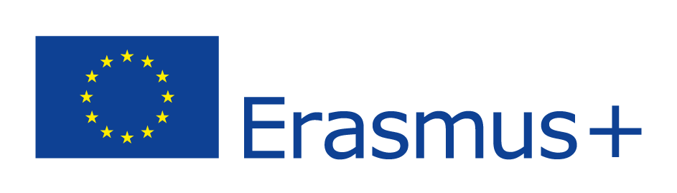

Logo 2: Funding
Erasmus+ is a programme that is funded by the European Union. Your EVS-program is an Erasmus+ program and is therefore also funded by the EU. This logo is also an essential graphic element that should appear in any material. This logo must be the same size as it is now, and it should be placed in the end of the material.

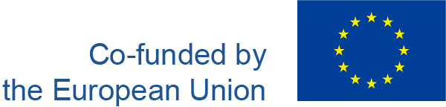

Logo 3: Dansk ICYE
The last logo that should appear in your material is the logo of Dansk ICYE. It is up to you where you locate the logo.

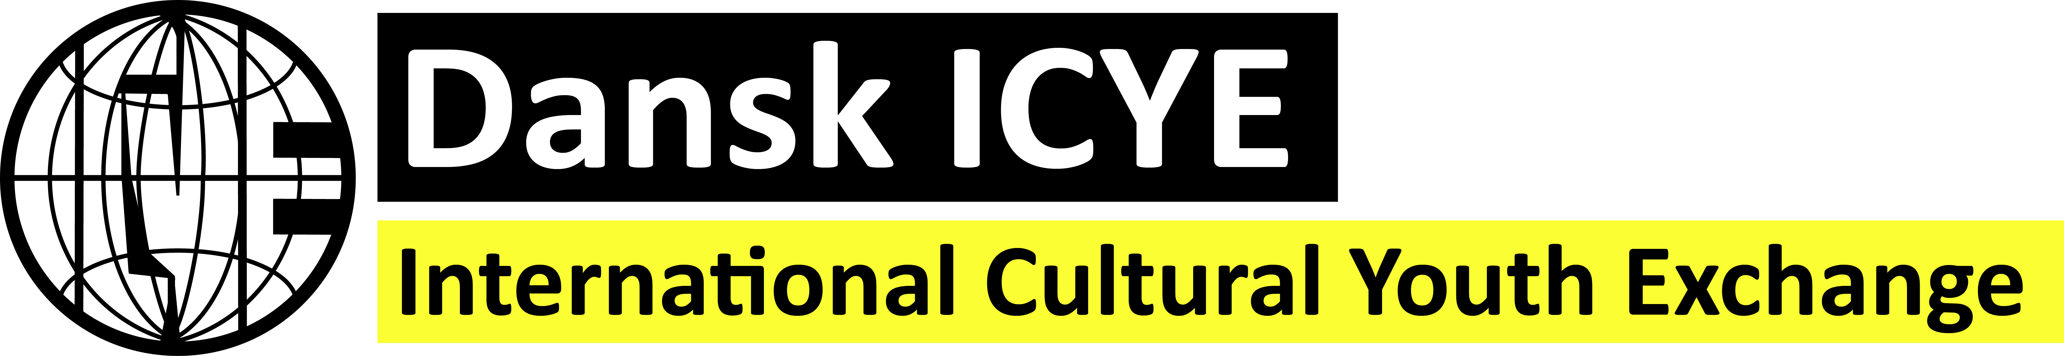

If it is possible, it will be really good to have a contact statement about Dansk ICYE. A contact statement could look like this:

If you want to read more about volunteering in Denmark or read more about Dansk ICYE and their exchange program, please visit www.icye.dk/volunteer-dk/.

